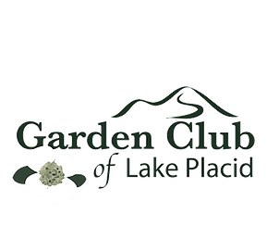
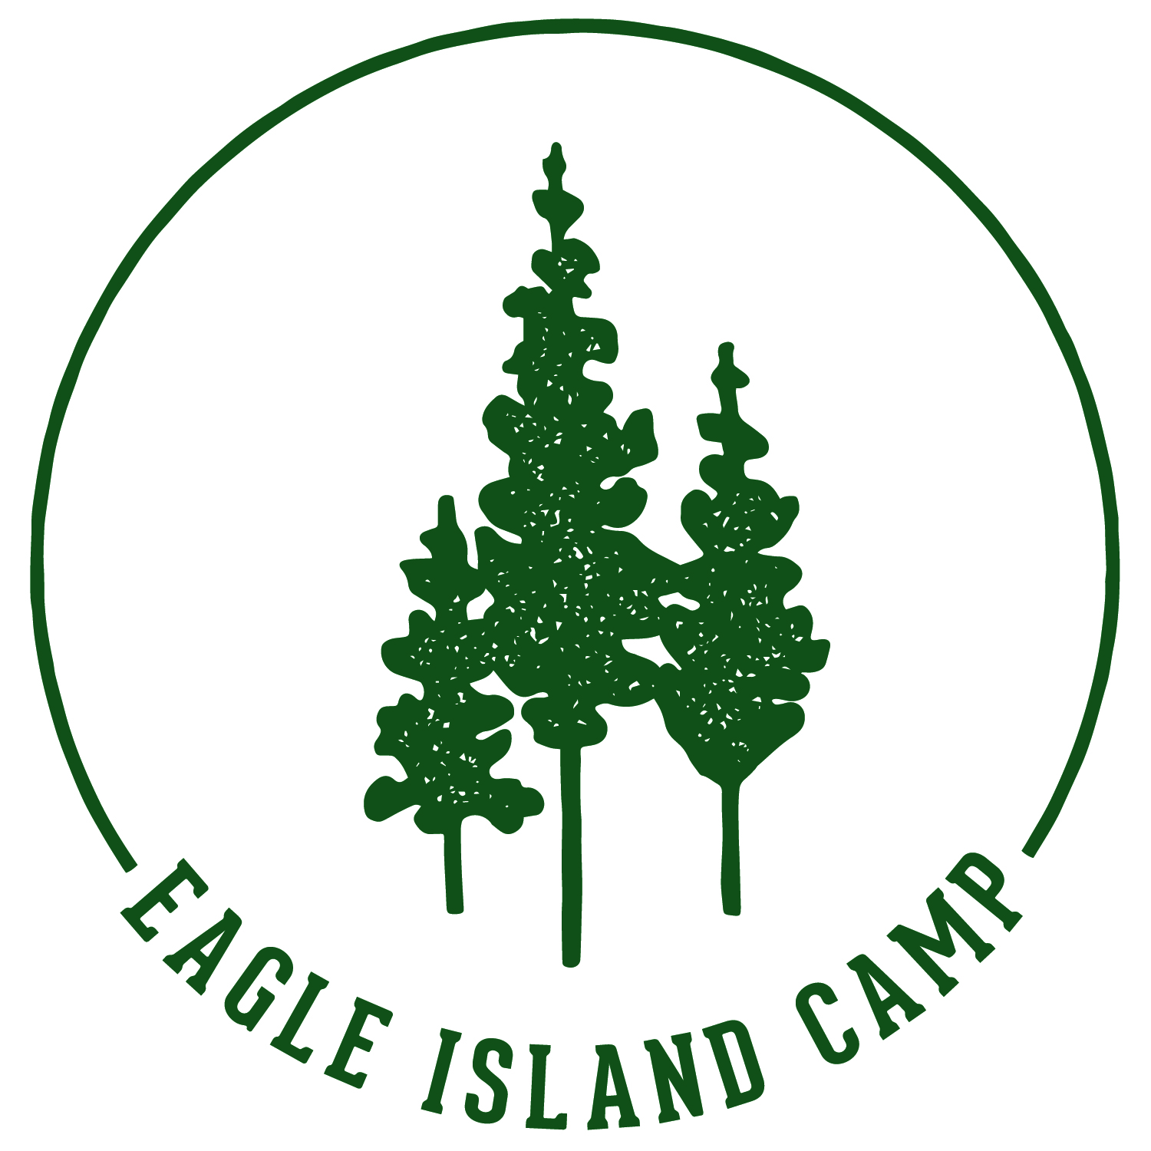
Application Form
GIRLS’ OVERNIGHT CAMPER FULL SCHOLARSHIP
at Eagle Island
Located on Upper Saranac Lake in the Adirondack Park

Name:

Mailing Address:

Email Address:

Entering Grade:

Telephone:

Why do you want to spend a week on Eagle Island?:

Eligibility Guidelines
- Camper is a girl entering grades 5-8
- Camper is a resident of the Tri-Lakes Region
- Camper is able to attend Session 1: July 12-July 17 or Session 2: July 19-July 24

Submit Application to: mulligan_am@hotmail.com or PO Box 603, Saranac Lake, NY 12983
Application Deadline: May 1, 2020

